**Name:-Anmol Vaswani**

**Roll No.:-67**

**Div:-D15A**

**Batch:-C**

**Experiment-1**

**Aim:-** To install and configure the Flutter Environment

**Theory:-**

Flutter:

Flutter is an open-source UI software development toolkit created by Google for building natively compiled applications for mobile, web, and desktop from a single codebase.

Key Features of Flutter:

Single Codebase: Flutter allows developers to write code once and deploy it on multiple platforms like Android, iOS, web, and desktop. Hot Reload: One of the most significant features of Flutter is its hot reload capability. Changes to the code can be instantly reflected in the running app, making the development process faster and more interactive.

Widget-Based Framework:

Flutter is based on a reactive widget framework. Widgets are the basic building blocks of the user interface, and they are used to create complex UIs. Rich Set of Widgets: Flutter provides a comprehensive set of customizable widgets, including material design and Cupertino-style widgets, to create visually appealing and platform-specific user interfaces.

Native Performance:

Flutter compiles to native code, resulting in high performance and smooth animations. It does not rely on a bridge to communicate with the native modules, enhancing the app's speed.

Dart Programming Language:

Flutter uses Dart as its programming language. Dart is an object-oriented, garbage-collected language that is easy to learn and provides a good developer experience.

Community and Ecosystem:

Flutter has a growing and active community that contributes to its ecosystem. There is a wide range of packages and plugins available on pub.dev, Flutter's package repository.

Flutter is a cutting-edge open-source framework developed by Google for crafting high-quality native interfaces on various platforms using a single codebase. It empowers developers to build visually appealing and responsive applications with ease. The framework is known for its expressive and flexible UI, enabling seamless development across iOS, Android, and web platforms. Flutter's hot-reload feature allows developers to instantly view changes, streamlining the development process. Its robust widget-based architecture facilitates the creation of beautiful and performant apps, making it a preferred choice for modern app development.

Android Studio, an advanced integrated development environment (IDE) created by Google, stands as the primary choice for Android app development. Boasting a user-friendly interface, powerful coding tools, and seamless integration with the Android platform, it provides developers with a robust environment for crafting high-performance applications. With features like intelligent code completion, real-time error checking, and an intuitive layout editor, Android Studio enhances productivity and accelerates the app development lifecycle. Its support for various Android devices, extensive testing capabilities, and built-in emulators contribute to creating reliable and efficient Android applications.

Flutter installed successfully:-

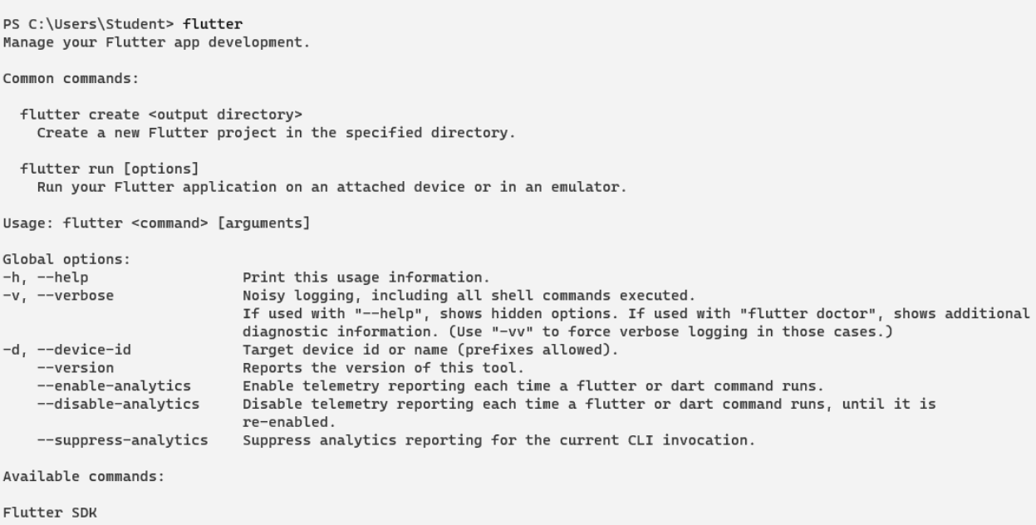

Flutter doctor

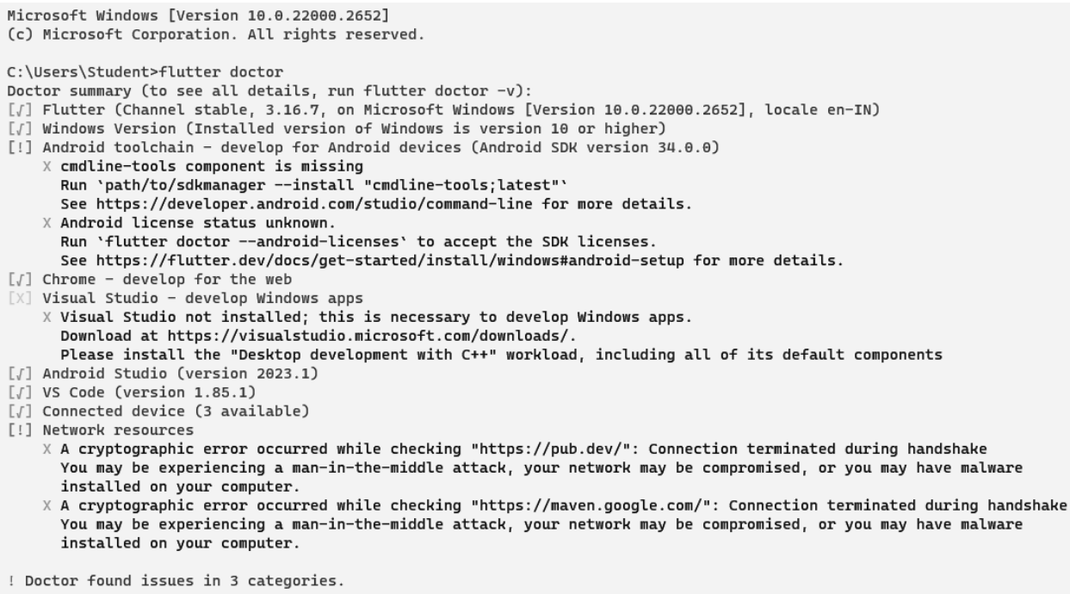

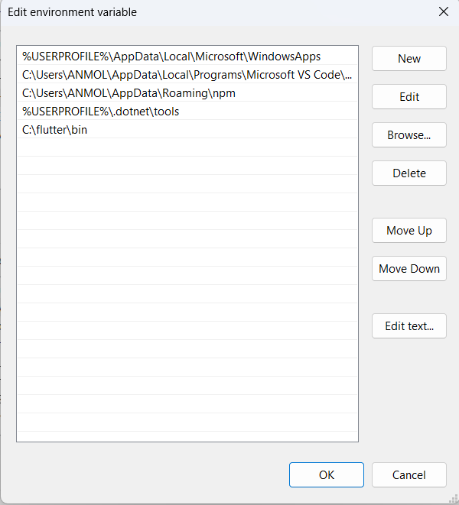

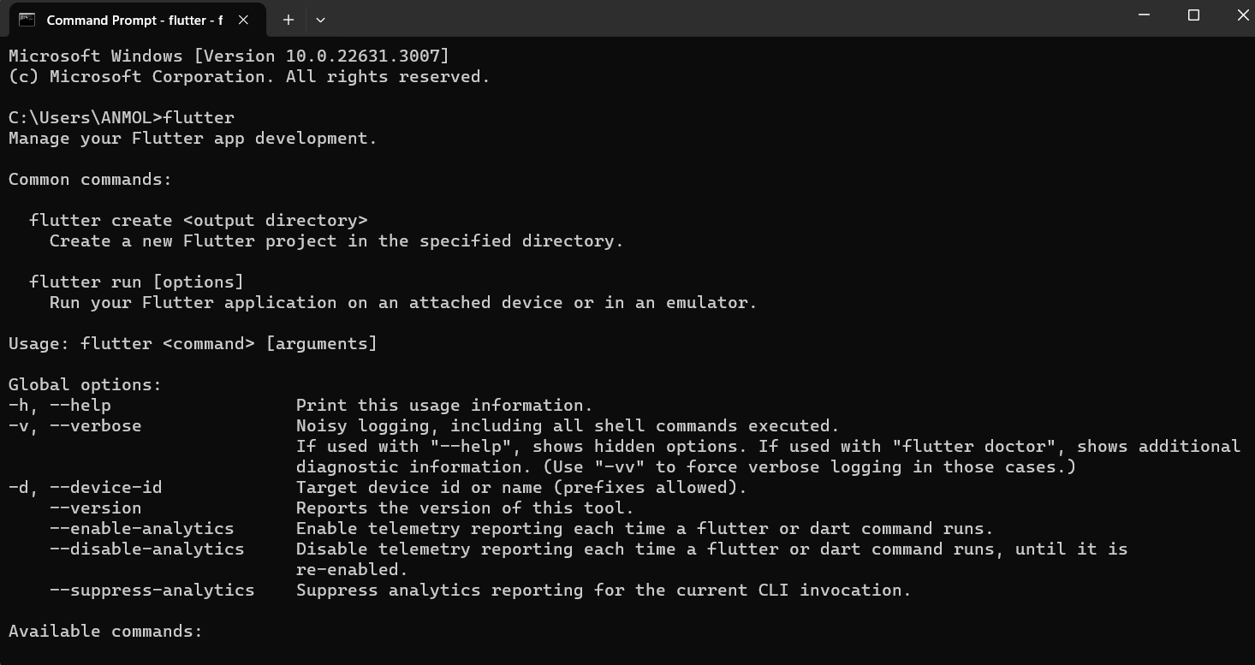

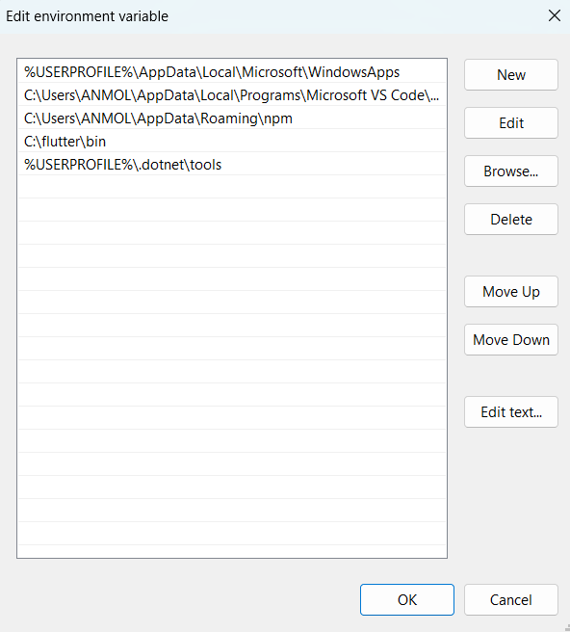

**Code:**

import 'package:flutter/material.dart';

void main() {

runApp(const MyApp());

}

class MyApp extends StatelessWidget {

const MyApp({Key? key}) : super(key: key);

@override

Widget build(BuildContext context) {

return MaterialApp( title: 'Welcome to Flutter',

home: Scaffold(

appBar: AppBar(

title: const Text('Welcome to Flutter'),

),

body: const Center(

child: Text('Hello World'),

),

),

);

}

}

**Output:-**

